**TASK-14**

**Name - Jainam Shah**

**ref ID- DIRSS2131**

Q1: We need to create directory inside the current user documents folder with the name as /home/user/Documents/photos, /home/user/Documents/videos, /home/user/Documents/audio

- copy all the files starting with the name either a,b, c from the folder of your Desktop [any folder] copy it inside the documents.

- from the documents if the file is starting with {a} copy it to videos

- if files or folders starting with { a or c} put it inside the audio

- put files starting with {b} inside the photos folder & make sure the file size is less than 5 MB

- Create the tar & compression of file inside the desktop for the all the 3 folders

- for the audio folder create a symbolic link inside the /tmp folder with any name

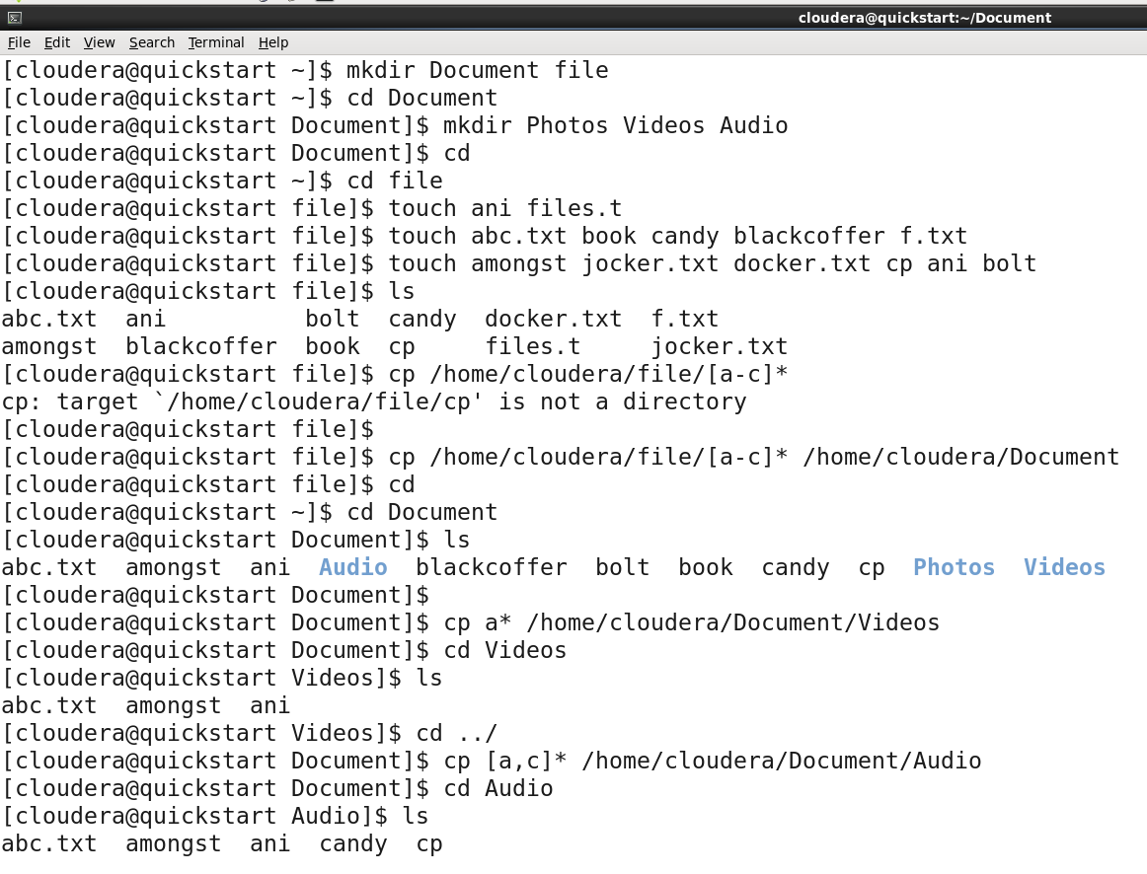

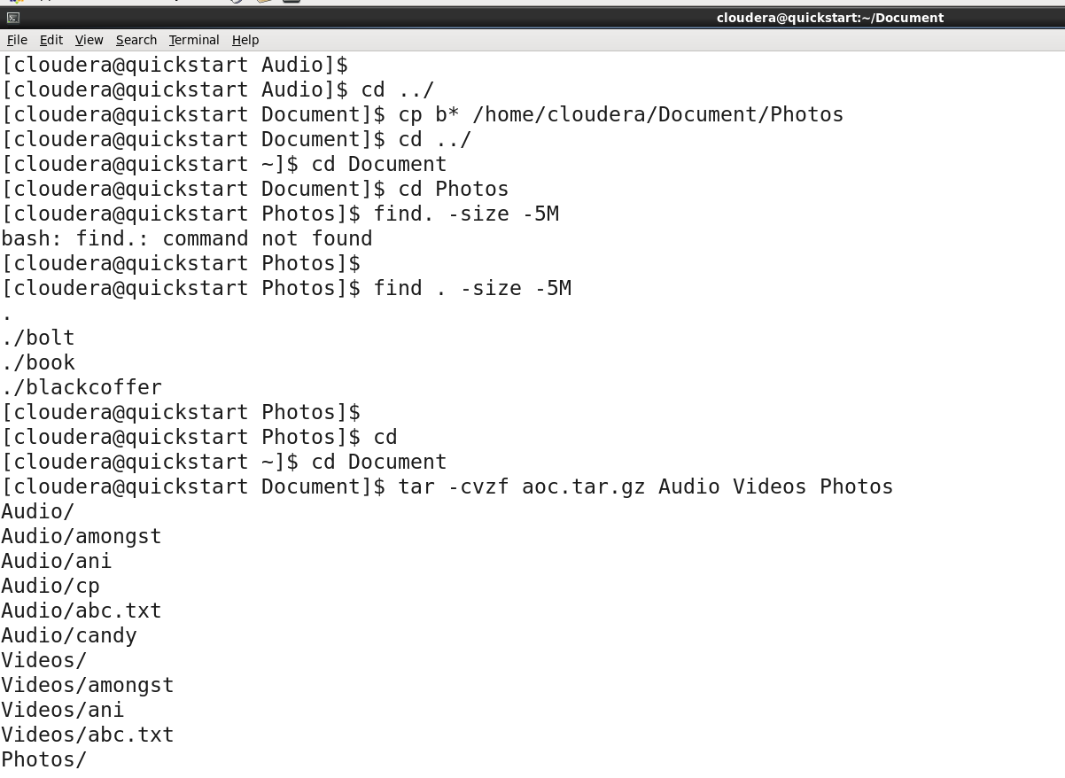

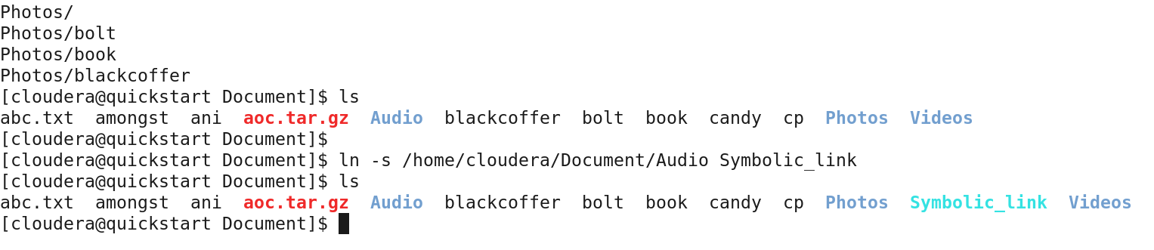

Q2: You need to create a user with the userid as 5000

- At the same time of creating the user set the password for the user

- Set the secondary group of that user as {sales}

- Also give the home directory to the user you are creating

- also add the comment as in form of date when creating user

- Set the shell of that user to {sh shell } [Using a single command]

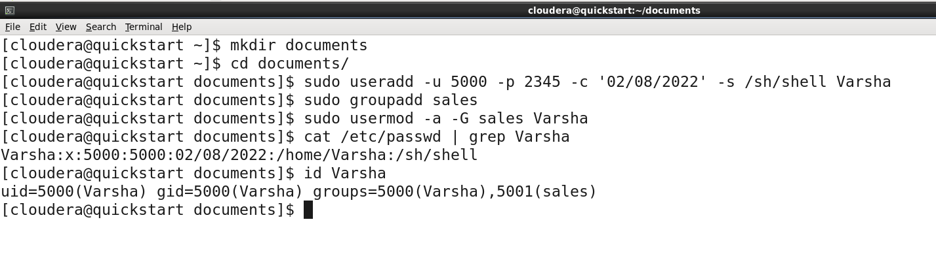

Q3: Create any four user ram, shyam, babu, aman

- Set their account to expire in 90 days

- Create a group sales & marketing add ram, shyam to sales

- add babu, aman to marketing

- make sure all the four user got the home directory

- give a comment "REGex users" at time of creating the user itself

[Group should be allocated to all the user at time of creating the user]

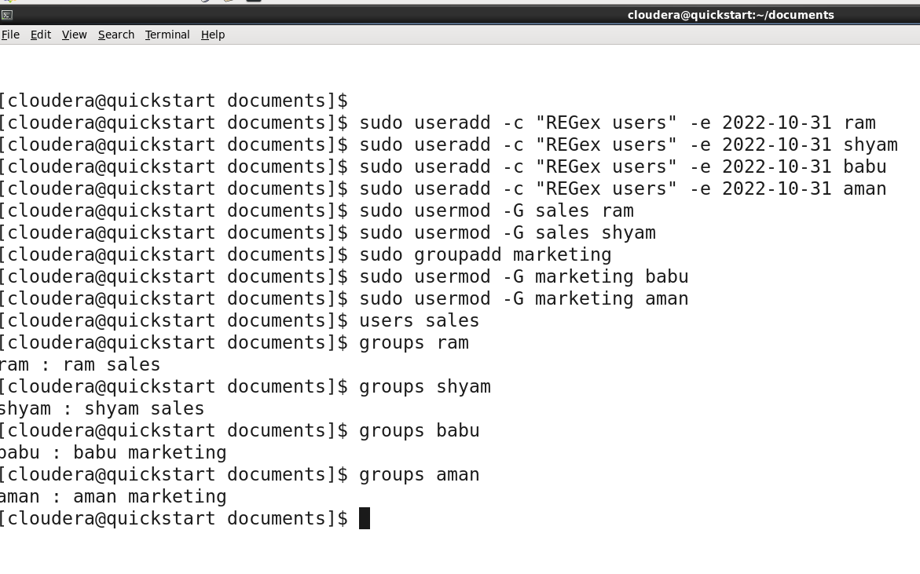

Q4: You have to change the username of the user, without deleting, changing or affecting the data its data

- Give the expiryd date of the user, that the account should expire after 2 days from the date you have created the account.

